17th June 2026

Dear parent/carer

This letter is to give you advanced notice that we will be operating an early close on Thursday, 2nd July 2026. This early closure is in light of the Mass at the Cathedral celebrating the 50th Anniversary of the school.

Students will still have an opportunity to purchase their lunch at lunch time and those on free school meals will also be able to purchase their lunch at this time.

All students will finish school at 2.10pm and will need to leave site promptly as there will be no staff available to supervise students after this time. Therefore, please ensure your child is collected 2.10pm.

A separate letter has been sent to those students who are joining and supporting with the Mass. Thank you for your support with this.

Yours faithfully,
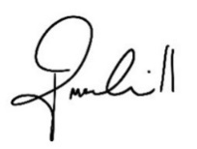

Mr. P McCahill
Headteacher

